Year 11 Chemistry
AECHE

Unit 1

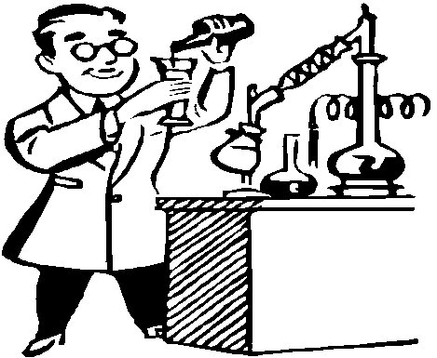

Chemical Reactions

Chemical reactions can be represented by chemical equations; balanced chemical equations indicate the relative numbers of particles (atoms, molecules or ions) that are involved in the reaction.
CHEMICAL EQUATIONS

- Chemical Reaction: process in which a chemical change occurs and new substances are formed.
- They are represented by chemical equations.
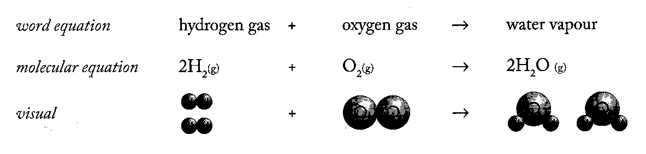
- Write balanced chemical equations for the following reactions:

- The burning of magnesium ribbon in oxygen gas to form solid magnesium oxide.

• Write the word equation (this you will often do in your head)

• Write the formulas of the reactants and products.

• Balance the equation

• Mark in the physical states of each species.

- The reaction of solid aluminium hydroxide and aqueous sulfuric acid to aqueous aluminium sulfate and water.

- The burning of gaseous butane, C₄H₁₀, in oxygen to form carbon dioxide gas and water.

EC 6.2 p44 NC 4.1 p206-8 QS 4.1 p209
Observations of chemical reactions are written to include states, colours, and odours (if gases) of reactants and products without making inferences.
- When you are asked to write observations for a reaction, describe the nature of the reactants (states, colours and odours) and the nature of the products (states, colours and odours)

- For the following reactions:
  - Write a balanced chemical equations
  - Write observations for the reaction

    - Powdered CuO is added to a H₂SO₄ solution.
CuO_{(s)} + 2H⁺_{(aq)} → Cu²⁺_{(aq)} + H₂O_{(l)}
A black solid dissolves in a clear colourless solution
to form a clear blue solution
    - Granulate zinc is added to hydrochloric acid.
____________________________________________________________________________________________________________________________________________________________________________________________________________________________________
    - A sulfuric acid solution is added to a copper (II) hydroxide suspension.
____________________________________________________________________________________________________________________________________________________________________________________________________________________________________
    - A hydrochloric acid solution is added to powdered aluminium oxide.
____________________________________________________________________________________________________________________________________________________________________________________________________________________________________
    - Carbon dioxide gas is bubbled through a sodium hydroxide solution.
____________________________________________________________________________________________________________________________________________________________________________________________________________________________________
    - Magnesium ribbon is added to an ethanoic acid solution.
____________________________________________________________________________________________________________________________________________________________________________________________________________________________________
    - A sulfuric acid solution is added to marble chips (CaCO₃).
____________________________________________________________________________________________________________________________________________________________________________________________________________________________________
Percentage composition of a compound can be calculated from the relative atomic masses of the elements in the compound and the mass of the compound
Percentage Composition
- Percentage composition describes the percentage by mass of each of the different elements present in the compound.
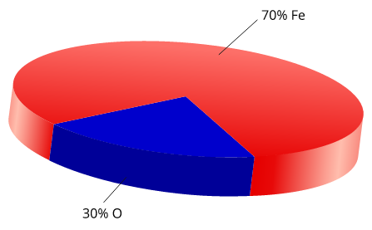
The pie chart shows the percentage composition, by mass, of iron(III) oxide, Fe2O3.

- $\% by mass of an element in a compound= \frac{mass of the element in 1 mol of the compound}{molar mass of the compound} x 100$

    - Calculate the percentage composition of sulphuric acid, H₂SO₄.

- Determine the percentage composition of water in nickel nitrate-6-water, Ni(NO₃)₂.6H₂O

- A 352 kg sample of gold ore contains 2.284 g of gold. What is the percentage composition of gold in the ore.

- PROBLEM SET
- Calculate the percentage composition of the following
  - methane, CH₄

  - oxalic acid, H₂C₂O₄.2H₂O

EC 4.4, 4.6 p30
NC 5.2 p233-4 QS 5.2 p234
The mole is a precisely defined quantity of matter equal to Avogadro’s number of particles
AVOGADRO'S NUMBER AND THE MOLE
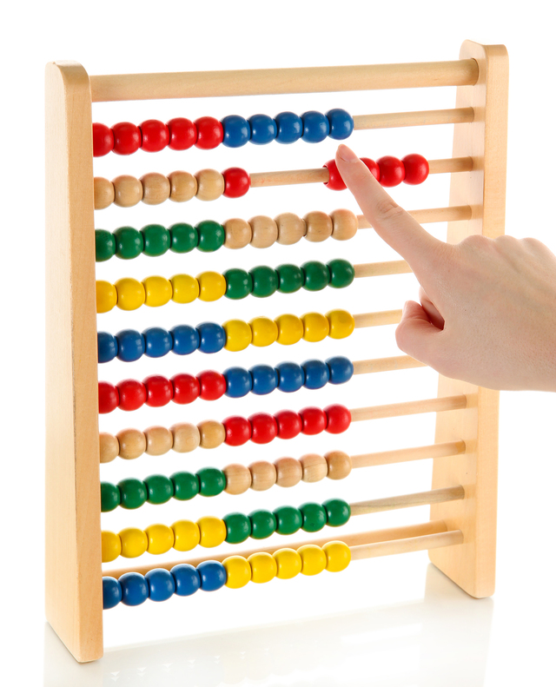
Chemists need a convenient method of measuring out quantities.

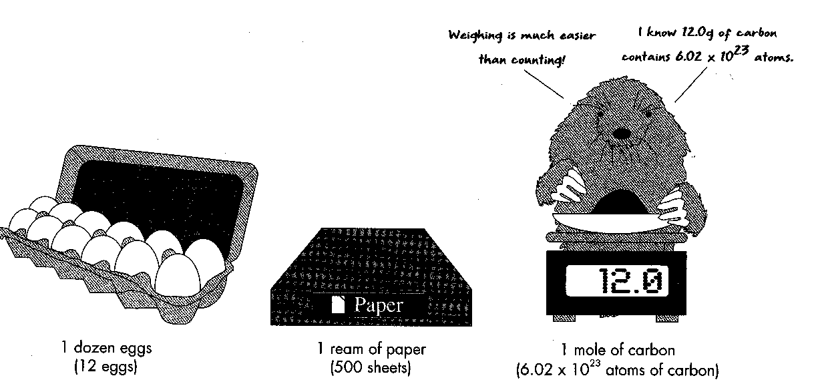

• The mole is the standard unit for describing the amount of a substance.
• One mole of a substance contains 6.022 x 10²³ particles (atoms, ions, molecules or formula units) of that substance.
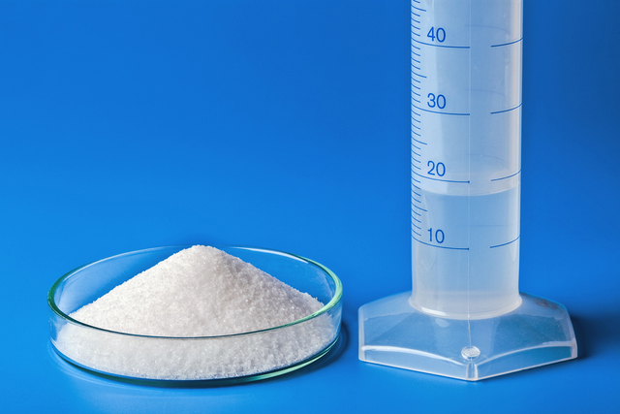
One mole of sodium chloride and one mole of water contain the same number of particles.
• The number of particles which make up a mole:

N = n x N_{A} where: N_{A} = Avogadro’s number, 6.022 x 10²³
N = the number of particles.
n = the moles of particles.
n = N .
6.022 x 10²³

EC 10.1 p80
NC 5.3 p235-6

The mole concept relates mass, moles and molar mass and, with the Law of Conservation of Mass, can be used to calculate the masses of reactants and products in a chemical reaction

Three Laws Of Chemistry

A. The Law of Conservation of Mass
During a chemical reaction there is no detectable gain or loss in mass - mass is neither created nor destroyed.

B. The Law of Constant Composition
All pure substances of the same compound contain the same elements combined together in the same proportions by mass.

C. The Law of Multiple Proportions
In different compounds, containing the same two elements, there is a simple whole number ratio between the masses of one element which combine with the fixed mass of another element.

Perform simple molar mass, and mass to mole calculations.

Molar Mass

• Molar mass is a mole of any substance which is equal to its relative atomic mass, relative molecular mass or relative formula mass expressed in grams.
• the mass in grams of Avogadro's number (6.022 x 10²³) of particles (atoms, ions, molecules or formula units) of that substance is also the molar mass of the substance.
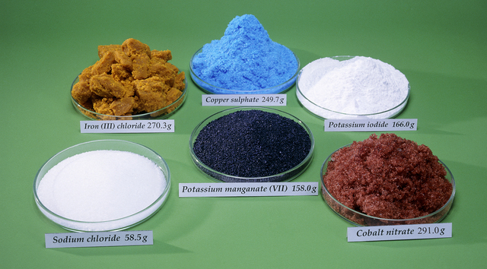
One mole of some common compounds.
- Comparing Molar Mass, M and Relative Mass, Mr

Substance | Formula | Relative mass- M_{r} | Molar Mass - M
Oxygen atoms | O | 16.00 | 16.00 g mol⁻¹
Oxygen gas | O₂ | 32.00 | 32.00 g mol⁻¹
Ammonia | NH₃ | 17.03 | 17.03 g mol⁻¹
Zinc | Zn | 65.39 | 65.39 g mol⁻¹
Iron (II) phosphate | Fe₃(PO₄)₂ | 357.49 | 357.49 g mol⁻¹

EC 10.2, 10.3 p80
NC p230-2 QS 5.1 p232

- PROBLEM SET

Find the molar mass of the following:

- aluminium cyanide

- calcium phosphate

- rubidium nitride

- manganese (II) dichromate

- potassium hydrogen phosphate

Relationship between moles and mass

- The relationship between the number of moles (n) and mass (m), of a substance is given by:
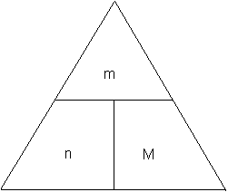
Number of moles = mass in gram
mass of 1 mole

n = m where: n = number of moles (mol)
M m = mass (g)
M = molar mass (g mol⁻¹)

NOTE:Round your answer to three significant figures. Don’t round during your working.

- How many moles are there in 9.25 g of ethanol (C₂H₅OH)?

- Calculate the mass of 4.00 mol of sodium hydroxide.

- Calculate the mass of nitrogen in 28.02 g of ammonium nitrate (NH₄NO₃).

EC 10.4 p81
NC p236-8 QS 5.3 p238-9
NC p239-41 QS 5.4 p243
- PROBLEM SET
- Calculate the mass of the following:
  - 3.50 mol of magnesium atoms.
By now you can short cut molar mass and do on your calculator

  - 0.750 mol of carbon dioxide molecules.

  - 0.0250 mol of sodium carbonate-10-water formula units.

  - 10.25 mol of strontium hydrogen sulfate

  - 2.05 x 10⁻³ mol lithium oxalate

- Calculate the number of moles contained in each of the following:
  - 64.00 g of oxygen gas

  - 19.95 g of argon gas

  - 390.0 g of acetylene (C₂H₂) molecules.

- If 2.50 moles of a substance contained 110.025 g, what was the molecular mass of the substance?
If the substance contained only oxygen and carbon, what do you think it might be?

- Calculate the mass of urea, CO(NH₂)₂, which contains 15.00 g of nitrogen.

Calculate the number of particles in a substance.

N = n x N_{A} where: N_{A} = Avogadro’s number, 6.022 x 10²³
N = the number of particles.
n = the moles of particles.
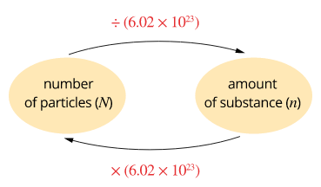
n = N .
6.022 x 10²³
Relationship between number of particles and amount of substance in moles.

- How many atoms of sulfur are there in 0.250 mol of sulfur atoms.

- How many moles of calcium carbonate formula units are there in 2.50 x 10²³ calcium carbonate formula units?

- A beaker contains 0.480 mol of pure sulfuric acid. Calculate the number of H₂SO₄ molecules, H atoms, S atoms and O atoms contained in this sample.

- PROBLEM SET
  - How many molecules of water are there in 3.50 mol of water molecules?

  - How many moles of sodium carbonate formula units are there in 3.01 x 10²³ formula units of sodium carbonate?

Perform mole-to-mole calculations and mass to mass calculations

REACTION STOICHIOMETRY
• A chemical reaction shows the relationship between the number of moles of reactants and products in a chemical reaction. The following chemical equation indicates:

Fe₂(SO₄)₃ + 12 KSCN 2 K₃Fe(SCN)₆ + 3 K₂SO₄

Every one mole of Fe₂(SO₄)₃, react with 12 moles of KSCN producing 2 moles of K₃Fe(SCN)₆ and 3 moles of K₂SO₄

The steps in working out stoichiometric calculations are as follows:

- Write a balanced equation.
(Leave out the states at this stage).

Identify, from the question, what information is ‘given’ or ‘known’.

Write the ‘known’ quantity under the equation.
e.g. 56 g, 24 L, 3.5 mol.

Identify, from the question, what information is to ‘be found’ or ‘unknown’.

Use a ? for the ‘unknown’ quantity.
e.g ? mol, ? g, ? L

Complete step 1 for the following:

- How many moles of carbon dioxide are produced when 0.795 moles of ethane is burnt in air?

_____C₂H₆ + _____O₂ _____CO₂ + _____H₂O
0.795 mol ? mol

- How many moles of aluminium are used up if 56 g of aluminium oxide is produced when the aluminium is burnt in air (with O₂)?

_____Al + _____O₂ _____Al₂O₃
? mol 56 g

- What mass of aluminium chloride is formed if 1.22 x 10⁻² g of hydrochloric acid reacts with excess aluminium?

- Calculate the number of moles of the known – n(known).

If the ‘known’ quantity is given as moles, leave it in moles.

If the ‘known’ quantity is given as mass, determine n(known) using .

If the ‘known’ quantity is given as volume, determine n(known) using .

If the ‘known’ quantity is given as a solution, determine n(known) using .

- Calculate n(known) for the following:

- How many moles of carbon dioxide are produced when 0.795 moles of ethane is burnt in air?

2C₂H₆ + 7O₂ 4CO₂ + 6H₂O

0.795 mol ? mol

- How many moles of aluminium are used up if 56 g of aluminium oxide is produced when the aluminium is burnt in air (with O₂)?

M(Al₂O₃) = 2 x 26.98 + 3 x 16.0 = 101.96 g Mol⁻¹
4Al + 3O₂ 2Al₂O₃
? mol 56 g

- What mass of aluminium chloride is formed if 1.22 x 10⁻² g of hydrochloric acid reacts with excess aluminium?

2Al + 6HCl 2AlCl₃ + 3H₂
0.0122 g ? g

- Determine the number of moles of the unknown – n(unknown) using the mole ratio from the balanced equation.

- Determine the mole ratios for the following:

- How many moles of carbon dioxide are produced when 0.795 moles of ethane is burnt in air?

2C₂H₆ + 7O₂ 4CO₂ + 6H₂O
0.795 mol ? mol

- How many moles of aluminium are used up if 56 g of aluminium oxide is produced when the aluminium is burnt in air (with O₂)?

4Al + 3O₂ 2Al₂O₃
? mol 56 g

- What mass of aluminium chloride is formed if 1.22 x 10⁻² g of hydrochloric acid reacts with excess aluminium?
2Al + 6HCl 2AlCl₃ + 3H₂
0.0122 g ? g

- Determine n(unknown) for the following

- How many moles of carbon dioxide are produced when 0.795 moles of ethane is burnt in air?

2C₂H₆ + 7O₂ 4CO₂ + 6H₂O
0.795 mol ? mol
__________ mol of CO₂

- How many moles of aluminium are used up if 56 g of aluminium oxide is produced when the aluminium is burnt in air (with O₂)?

4Al + 3O₂ 2Al₂O₃
? mol 56 g

=

- What mass of aluminium chloride is formed if 1.22 x 10⁻² g of hydrochloric acid reacts with excess aluminium?
2Al + 6HCl 2AlCl₃ + 3H₂
0.0122 g ? g

4. Convert n(unknown) into the quantity required in the question.

If the moles of the ‘unknown’ quantity is required, this is the answer.

If the mass of the ‘unknown’ quantity is required, determine m(unknown) using .

If the volume of the ‘unknown’ quantity is required, determine V(unknown) using
.
If the concentration of the ‘unknown’ quantity is required, use .

- Convert n(unknown) into the quantity required.

- How many moles of carbon dioxide are produced when 0.795 moles of ethane is burnt in air?

2C₂H₆ + 7O₂ 4CO₂ + 6H₂O
0.795 mol ? mol

1.59 mol of CO₂

n(CO₂) =

- How many moles of aluminium are used up if 56 g of aluminium oxide is produced when the aluminium is burnt in air (with O₂)?

4Al + 3O₂ 2Al₂O₃
? mol 56 g

n(Al) = __________ mol of Al required

- What mass of aluminium chloride is formed if 1.22 x 10⁻² g of hydrochloric acid reacts with excess aluminium?
2Al + 6HCl 2AlCl₃ + 3H₂
0.0122 g ? g

- There are many different types of calculations that you will be required to do including moles to moles, mass to mass, moles to mass, moles to volume, volume to volume, volume to mass etc.

- Each process is the same.

  - Write a balanced equation and identify your known and unknown.
  - Calculate the number of moles of the known.
  - Use the mole ratio to determine the number of moles of the unknown.
  - Convert the number of moles of unknown to the required quantity.

- Useful Formulae

MASS  (m) |  | MOLES  (n) |  | VOL of gas at STP
 |  | VOLUME of solution |  | VOL of gas not at STP

R = 8.314 (P in kPa)

STP: 273.15 K and 100.0 kPa

EC 11.1, 11.2, 11.3 p84-5

NC 5.6 p248-53 QS 5.6 p253

Chap Review p 255-6

- Mole to mole example

Propane gas (C₃H₈) burns in oxygen to form carbon dioxide gas and water vapour. If 15.0 mol of propane is burnt, how many mol of carbon dioxide is produced?

STEP 1:

STEP 2:

STEP 3:

STEP 4:

- Mass to mole example

Oxygen gas can be produced from potassium chlorate as shown in the equation below. Calculate the number of moles of oxygen that would be produced from 20.0 g of potassium chlorate.

STEP 1:

STEP 2:

STEP 3:

STEP 4:

- Mole to mass example

When sodium hydrogen carbonate is heated it decomposes to sodium carbonate, carbon dioxide and water. Calculate the mass of sodium carbonate produced from the decomposition of 5.50 mol of sodium hydrogen carbonate.

STEP 1:

STEP 2:

STEP 3:

STEP 4:

- Mass to mass example

Determine the mass of lead (II) iodide precipitated by adding excess potassium iodide to 15.0 g of lead (II) nitrate in solution.

STEP 1:

STEP 2:

STEP 3:

STEP 4:

Calculations involving limiting reagents
Unless all reactants are in perfect stoichiometric ratios, one will be the limiting reagent and the others will be in excess.

- In most situations where a chemical reaction is performed one of the two reagents will be present in excess, i.e. some of it remains when the reaction is finished.

- The reagent that is fully consumed is known as the limiting reagent.

- When the amount of both reagents is given it is important to determine which of these substances is the limiting agent as the limiting reagent fixes the amount of all other substance used or produced in the reaction.

- One method for identifying the limiting reagent is to compare the stoichiometric and actual ratios of the two reagents.

- 1.5 kg H₂SO₄ was accidentally spilled on the lab floor. A clever year 11 student immediately realised that she can neutralise it with NaOH. She found 2.00 kg of this base, made a solution and add that to the acid. Let’s assume the reaction was complete.

Determine the limiting reagent and then calculate the mass of the salt that will be produced.

Mass NaOH
Determine limiting reagent
Mass H₂SO₄ ↓
Mole Na₂SO₄
↓
Mass Na₂SO₄

Step 1: Balanced equation
2NaOH + H₂SO₄ Na₂SO₄ + 2H₂O

Step 2: Calculate the moles of each reactant
n(H₂SO₄) = m = 1.5 x 10³ = 15.3 mol
M 98.076

n(NaOH) = m = 2.00 x 10³ = 50.0 mol
M 39.998

Step 3: Compare the mole ratio
2 mol NaOH reacts with 1 mol H₂SO₄
50.0 mol NaOH reacts with 25 mol H₂SO₄

Step 4: Decide the limiting reagent
Need 25 mol H₂SO₄ but only have 15.3 mol
Not enough H₂SO₄ therefore limiting reagent

Step 5: Identify the unknown and relate it to the limiting reagent
1 mol H₂SO₄ produce 1 mol Na₂SO₄
n(H₂SO₄) = n(H₂SO₄) = 15.3 mol

Step 6: Convert the moles to mass
m(H₂SO₄) = n x M
= 15.3 x 142.o4
= 2.17 kg

- Hydrochloric acid containing 10.0 g of HCl was reacted with 10.0 g of calcium carbonate to produce carbon dioxide gas. Determine:

a. the limiting agent
b. the mass of CO₂ _{(g)} produced.
c. the mass of unused reactant.

- A 3.200 g sample of NaOH is added to a solution containing 1.125 g of H₂SO₄. Determine:

a. the limiting reagent;
b. the mass of sodium sulphate formed in solution;
c. the mass of unused reactant remaining in solution.

EC 11.6, 11.7, 11.8 p89-90

Chemical reactions and phase changes involve enthalpy changes, commonly observable as changes in the temperature of the surroundings and/or the emission of light.
ENERGY EFFECTS

CHEMICAL CHANGES IN CHEMICAL REACTIONS

- Chemical changes are usually accompanied by some form of energy change. Some example of energy changes during chemical reactions are the following:

- Heat energy and light energy are released when magnesium burns in air, or when iron or aluminium filings are sprinkled into a gas flame or when wood burns.
- Heat energy from the combustion of petrol in car engines is converted to mechanical energy.
- Many reactions in this course release heat energy: the reaction mixture becomes hotter and heat is transferred to the surroundings. Some other reactions absorb energy: the reaction mixture become colder and takes heat from the surroundings.

- Many reactions are carried out for the sole purpose of obtaining the energy they release and the chemical products of the reaction may be of little or no value.
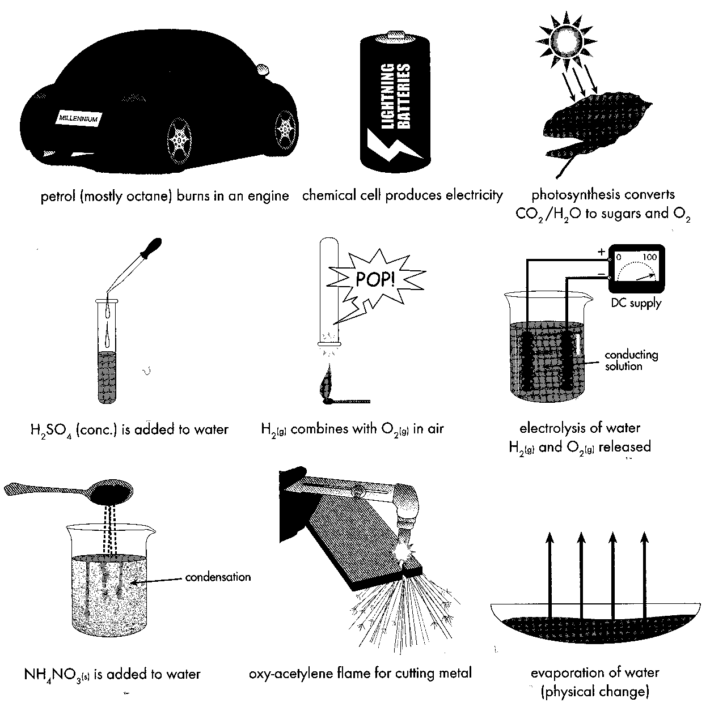
- Energy is neither created nor destroyed; it can only be transformed from one form to another.
- If heat energy is released during a chemical reaction, energy must have been present in some other form in the reactants.

EC 13.1, 13.2 p104

Endothermic and exothermic reactions can be explained in terms of the Law of Conservation of Energy and the breaking of existing bonds and forming of new bonds; heat energy released or absorbed by the system to or from the surroundings, can be represented in thermochemical equations.

Exothermic and Endothermic Reactions
- Energy released from reactions when reactants have a higher chemical energy than the products. The chemical energy of a substance is a type of potential energy stored within the substance.

- Enthalpy is the name given to the stored chemical energy or the heat content of a substance, denoted by the symbol, H. If enthalpy decreases within a reaction a corresponding amount of energy is released to the surroundings.
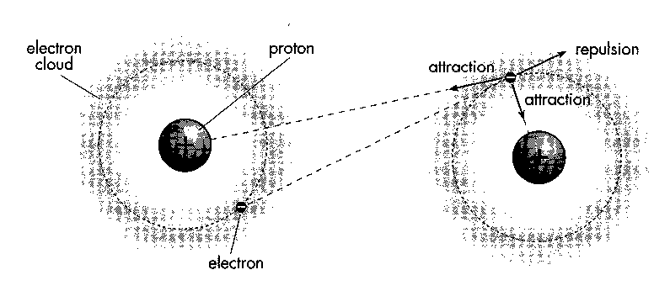
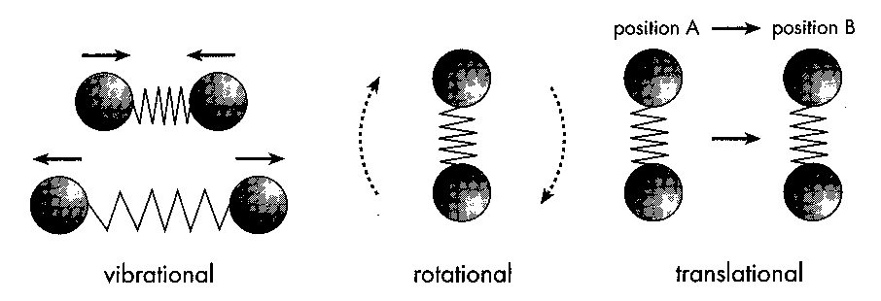
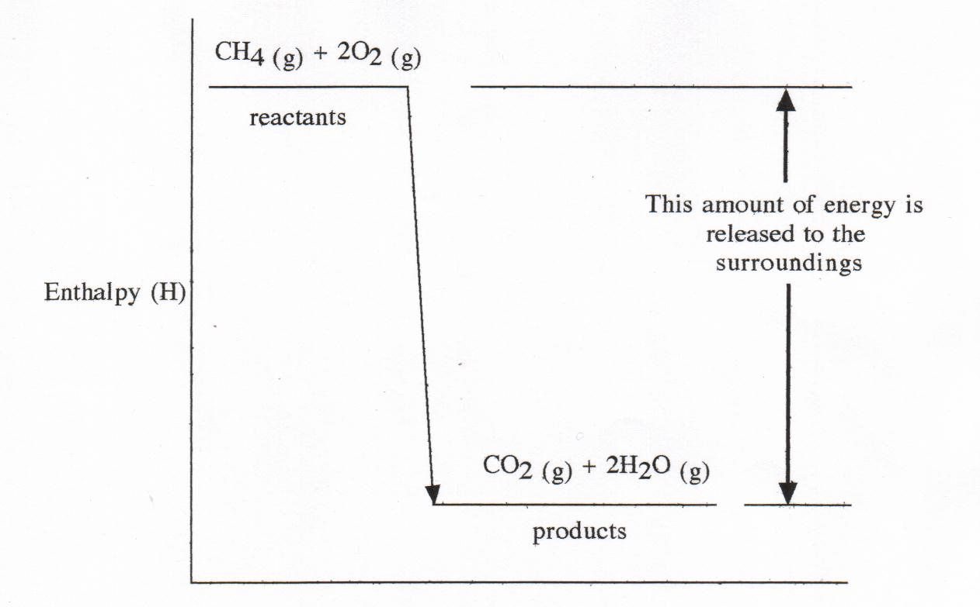
EXOTHERMIC REACTION:
- Consider Methane burning in air:

CH_{4(g)} + 2O_{2(g)} → CO _{(g)} + 2H₂O _{(g)} + energy
- Heat given out corresponds to the decrease in enthalpy.
- The enthalpy difference between the reactants and the products is equal to the amount of energy released to the surroundings.

Exothermic reaction- a reaction in which energy is released to the surroundings - the enthalpy is lower for the products than the reactants. The reaction mixture becomes hotter and transfers heat to the surroundings.

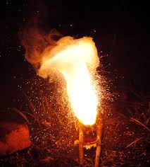

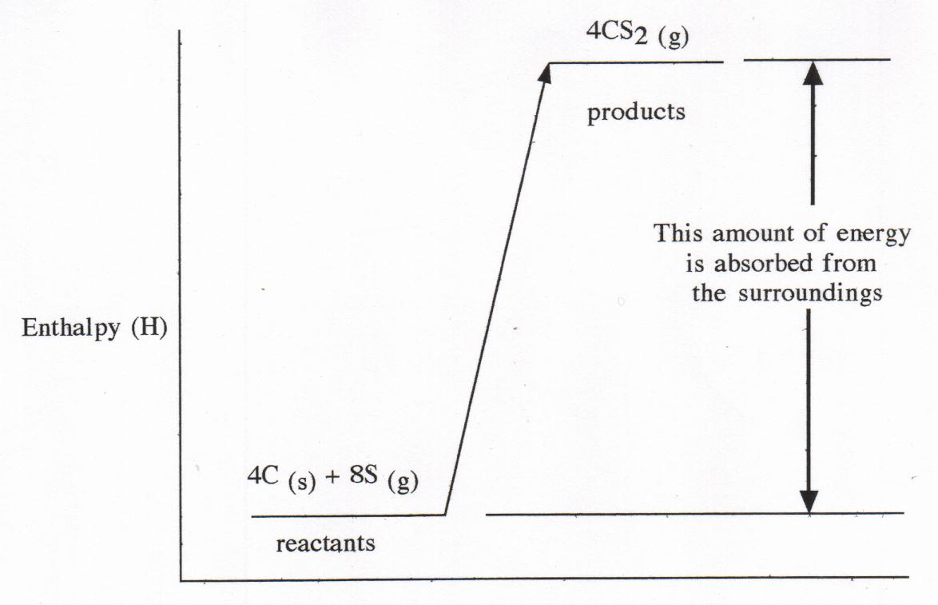
ENDOTHERMIC REACTION:
- The enthalpy changes that occur in a reaction that absorbs energy, results in the products having a greater enthalpy than the reactants. Carbon disulfide can be manufactured according to the following equation:

4C _{(s)} + 8S _{(g)} → 4CS₂ _{(g)}

- Enthalpy of the products is greater than the reactants.
- The enthalpy difference between the reactants and the products is equal to the amount of energy absorbed from the surroundings.

- The enthalpy difference between the reactants and the products is equal to the amount of energy absorbed from the surroundings.

Endothermic reaction - a reaction in which energy is absorbed from the surroundings - the enthalpy of the products is greater than that of the reactants. The reaction mixture becomes colder and takes heat from the surroundings.

EC 13.3 p104
PROBLEM SET:

1. For each of the following processes:

• State whether the process would be exothermic or endothermic.
• Indicate whether the reactants or the products have higher enthalpy.
• Identify whether heat would be absorbed or released to the surroundings.
An endothermic reaction produces an instant cold pack.
- Burning kerosene

b. Mixing solid Ba(OH)₂ and solid NH₄SCN. The following reaction takes place and the reaction mixture becomes colder.
Ba(OH)_{2 (s)} + 2NH₄SCN _{(s)} → Ba²⁺ _{(aq)} + 2SCN⁻ _{(aq)} + 2NH₃ _{(aq)} + 2H₂O _{(l)}

c. Melting ice at 0 ºC.

- Condensing steam at 100 ºC.

2. In the evaporation of water the enthalpy of the water increases. In view of this fact, explain how perspiration helps the human body to keep cool.

3. In an explosion using dynamite to destroy a city building, describe the following:
- The enthalpy change in the reacting system.

- The energy change in the surroundings.

STORED CHEMICAL ENERGY
- Exothermic or endothermic reactions are associated with a decrease or increase in the enthalpy of the substance involved.
- The enthalpy of a substance represents the stored chemical energy of the substance involved and depends on the chemical bonding present in the substance.

- When chemical bonds are broken:
- the breaking of chemical bonds absorbs or requires energy.
- the formation of chemical bonds releases energy.

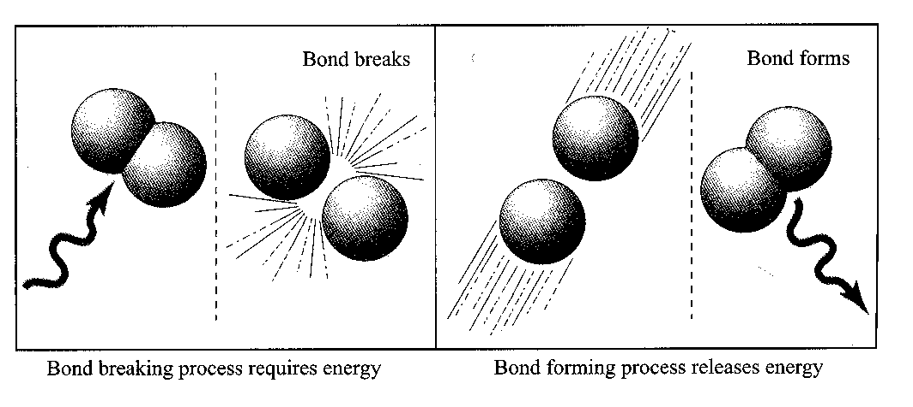

- The quantity of energy released when a bond forms is equal to the quantity of energy absorbed when such a bond is broken.
- When a chemical bond is broken, an increase in enthalpy in the system occurs.

2H₂ _{(g)} + O_{2 (g)} → 2H₂O _{(g)}

- Two H - H bonds and one O = O are broken.
- Four O - H bonds are formed.
- Energy is released from forming the four O - H bonds.
- The products have a lower enthalpy than the reactants - exothermic reaction.

- Chemical reactions usually involved the breaking and making of chemical bonds.
- Generally, if the bonds formed are weaker or fewer than those broken, energy will be absorbed.
- If the bonds formed are stronger or more numerous than those broken, energy will be released.

PROBLEM SET:

1. Compare the enthalpies of the following:
- A hydrogen molecule and two separate hydrogen atoms.

b. A hydrogen fluoride molecule and separate fluorine and hydrogen atoms.

2. Identify the bonds which are broken and those which are formed in the following reactions.
a. N₂ _{(g)} + 3H₂ _{(g)} → 2NH_{3 (g)}

b. NH₄NO₃ _{(s)} → N₂ _{(g)} + 2H₂O _{(g)}

EC 13.5 p105
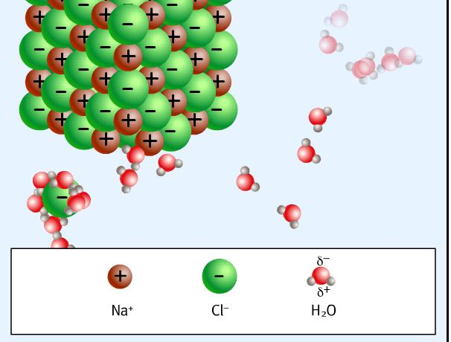
HEAT OF SOLUTION

- When NaCl dissolves in water it dissociates into Na⁺ ions and Cl⁻ ions.

- Breaking the ionic bonds in the NaCl lattice is a process that requires energy – it is ENDOTHERMIC.

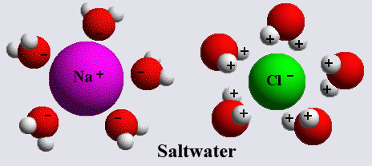
- If the solute and the solvent attract each other this will release energy – it is EXOTHERMIC.

- When water surrounds the sodium ions and chloride ions, energy is required.

- This process is known as hydration.

- When the water attracts the sodium ions or the chloride ions a weak “ion-dipole interaction” is formed between the water and the ion which releases energy.
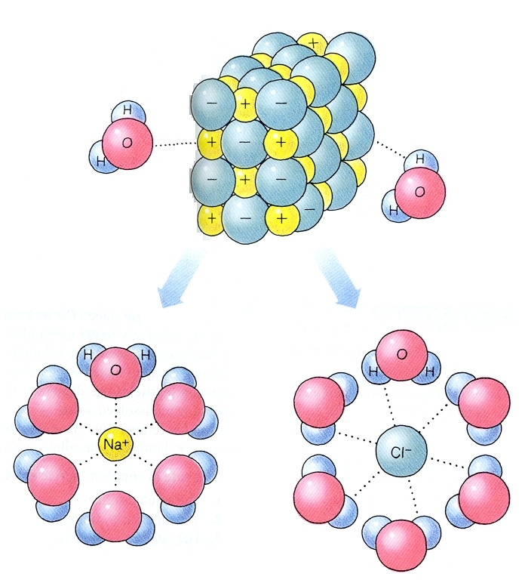


- If H _{bond breaking} > H _{hydration} = ENDOTHERMIC
- If H _{hydration} > H _{bond breaking} = EXOTHERMIC

DESCRIBING ENERGY CHANGES IN CHEMICAL REACTIONS

- The symbol ΔH represents the heat of reaction or change in enthalpy.
Δ= delta = change
ΔH = H(products) - H(reactants)
heat of enthalpy of enthalpy of
reaction products of reactants

  - ΔH for an exothermic reaction has a negative value.
  - ΔH for an endothermic reaction has a positive value.

Enthalpy Changes for Exothermic and Endothermic Reactions
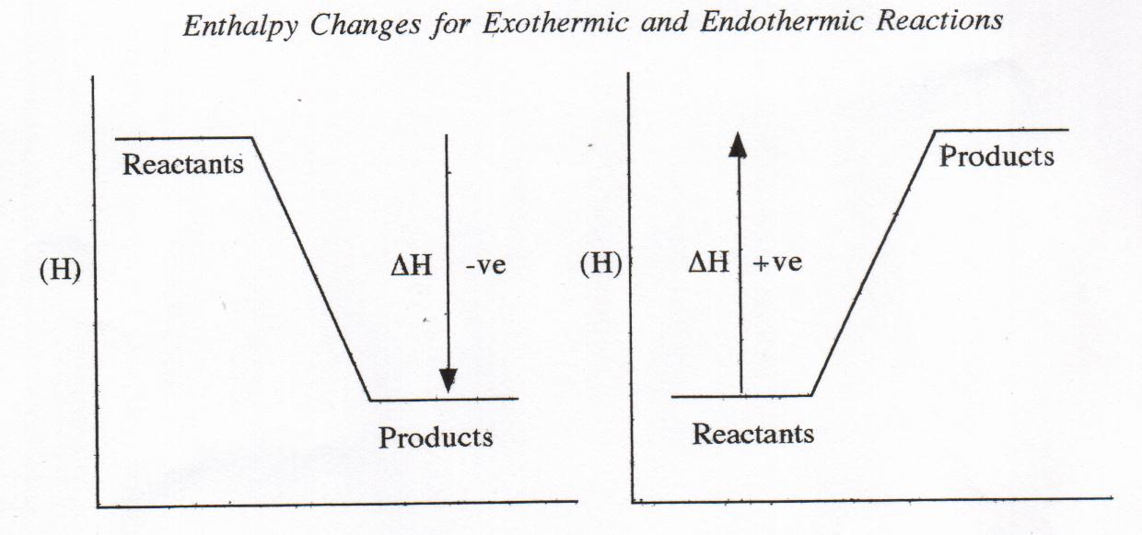
• Exothermic reaction • Endothermic reaction
• ΔH is negative • ΔH is positive
• Heat released to surroundings. • Heat absorbed from surroundings.
- Endothermic - the final enthalpy is greater than the initial enthalpy and ΔH is positive; gain in enthalpy is accompanied by the transfer of energy from the surroundings to the system.

- Exothermic - the final enthalpy is less than the initial enthalpy and ΔH is negative; loss in enthalpy is accompanied by the release of energy from the system to the surroundings.

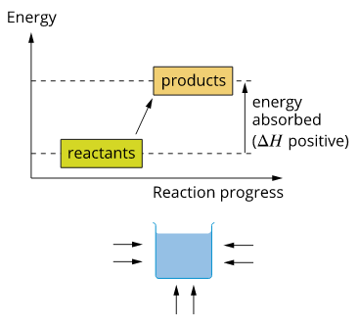
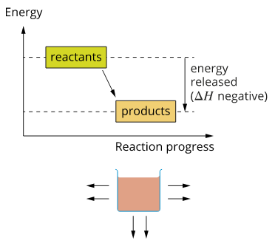
For an endothermic reaction, the energy of the reactants is lower than the energy of the products so energy is absorbed during the reaction.
In an exothermic reaction, the energy of the reactants is higher than the energy of the products, so energy is released during the reaction.

- The enthalpy change is shown in a thermochemical equation.

- H₂O _{(g)} → H₂ _{(g)} + ½ O_{2 (g)} ΔH = +242 kJ

242 kJ of heat is absorbed in the decomposition of one mole of steam.

- S _{(s)} + O_{2 (g)} → SO₂ _{(g)} ΔH = -242 kJ

242 kJ of heat is released when one mole of S reacts with oxygen to form sulphur dioxide.

- The heat term is written as a product in exothermic reaction and as a reactant in a endothermic reaction.

- C _{(s)} + H₂O _{(g)} + 131 kJ → CO _{(s)} + H_{2 (g)} Endothermic reaction; ΔH = +131 kJ

- 2S _{(s)} + 3O₂ _{(g)} → 2SO₃ _{(g)} + 792 kJ Exothermic reaction; H = -792 kJ

EC 13.4 p105

PROBLEM SET:

1. For the following reactions:
• Draw a diagram showing the enthalpy of the reactants and products.
• State whether the reaction is exothermic or endothermic.
• Predict whether the temperature of the surroundings would increase or decrease.
• Rewrite the equation including the energy term as part of the equation:

a. CO _{(g)} + ½ O₂ _{(g)} → CO_{2 (g)} ΔH = -283 kJ

b. ½H₂ _{(g)} + ½ I₂ _{(g)} →HI _{(g)} ΔH = +26 kJ

2. For the following reactions:
• State whether the reaction is exothermic or endothermic.
• State the value of ΔH for the reaction.

- C _{(s)} + H₂O _{(g)} + 131 kJ → CO₂ _{(g)} + H_{2 (g)}

- 2S _{(s)} + 3O₂ _{(g)} → 2SO₃ _{(g)} + 792 kJ

3. 824 kJ of energy is released when one mole of iron metal is burnt in oxygen gas and converted to iron (III) oxide. Write an equation for this reaction, indicating the heat energy involved which you will need to calculate from the balanced equation.

PROBLEM SET:
1. Compare the heats of reaction for the following processes:

H₂ _{(g)} + O₂ _{(g)} → H₂O₂ _{(l)} ΔH = -188 kJ
H₂O₂ _{(g)} → H₂O₂ _{(l)} ΔH = -51 kJ

and explain the difference in terms of the processes involved.

- For the following processes:
    - State whether the process would be exothermic or endothermic.
    - Indicate whether the reactants or products have the higher enthalpy.
    - Identify whether heat would be absorbed from or released to the surroundings.
- Burning magnesium

- Subliming carbon dioxide

- Adding concentrated sulfuric acid to water, which results in the temperature of the solution increasing.

- Predict the sign of ΔH for the following processes:
- The formation of dew.
- O_{2 (g)} → 2O_{(g)}
- H_{(g)} + I_{(g)} → HI_{(g)}
- CaCO_{3 (s)} + 178 kJ → CaO_{(s)} + CO_{2 (g)}

- Identify the following reactions as exothermic or endothermic.
a. N_{2 (g)} + 3H_{2 (g)} → 2NH_{3 (g)} ΔH = -92 kJ
b. 6CO_{2 (g)} + 6H₂O_{(l)} → C₆H₁₂O_{6 (aq)} + 6O_{2 (g)} ΔH = +2803 kJ
c. 2C_{(s)} + O_{2 (g)} → 2CO_{(g)} + 222 kJ
d. 2H_{2(g)} + 484 kJ → 2H_{2 (g)} + O_{2 (g)}

- For the reaction: H_{2 (g)} + Cl_{2 (g)} → 2HCl_{(g)}
- Identify which bonds are broken.
- Identify which bonds are formed
- Given that ΔH = -184 kJ for this reaction, is more energy involved in bond breaking or bond forming?

- Instant cold packs used to treat sporting injuries often contain NH₄NO₃ and a plastic bag of water. When the plastic bag is broken the ammonium nitrate dissolves as follows:
NH₄NO_{3 (s)} → NH₄⁺_{(aq)} + NO₃⁻ _{(aq)}

      - Is this reaction exothermic or endothermic?
      - Do the products or reactants have a higher enthalpy?
Draw a diagram showing the enthalpy of the reactants and products.

EC 13.6 p105-6
NC p213-216

Specific heat capacity

Specific Heat Capacity

- Each substance has a different ability to hold heat e.g. grass and sand on a hot day. They have different capacities to hold the heat called heat capacities.

- The heat capacity of a defined system is the amount of heat (usually expressed in calories, kilocalories, or joules) needed to raise the system's temperature by one degree (usually expressed in Celsius or Kelvin).
- It is expressed in units of thermal energy per degree temperature. To aid in the analysis of systems having certain specific dimensions, specific heat capacity can be used.

Specific Heat Capacity (c)
- The amount of heat needed to increase the temperature of one gram of a substance by one degree is the specific heat capacity.

- Units of specific heat (c) are: Jg⁻¹K⁻¹ (or Jg⁻¹C⁻¹ as 1 degree Celsius is the same as 1 Kelvin)

- Because the specific heat of lead is 0.128 Jg⁻¹C⁻¹, 0.128 Joules of heat is required to raise one gram of lead by one °C.

- To calculate the total amount of energy needed to heat a substance is dependant on:
- Mass of the substance (m)
- Substance (its specific heat - c)
- Increase in temperature required (ΔT)
- This can be written as a mathematical equation:
Q = mcΔT or mc(T₂ – T₁)

where: Q = heat gained or lost when temperature changes in joules (J)
m = mass of substance in grams (g)
c = specific heat (Jg⁻¹K⁻¹) and is unique for each substance
T = temperature in ⁰C or K. NOTE: T₂ is always the higher
temperature so there is never a negative answer.

Example:
A 400 g block of iron is heated from 22⁰C to 52⁰C. How much heat is absorbed by the iron? (Specific heat of iron is 0.450 Jg⁻¹K⁻¹)
m = 400g Q = mcΔT
T₁ = 22⁰C = mc(T₂ – T₁)
T₂ = 52⁰C = 400 x 0.450 x (52 – 22)
c = 0.450 Jg⁻¹K⁻¹ = 400 x 0.450 x 30
= 5400 J

Example:
25 g of water at 90.0⁰C has 3657.5 J of heat energy removed from it. What is its final temperature? (Specific heat of water is 4.18 Jg⁻¹K⁻¹)

Example:
50.0 g glass (specific heat of 0.670 Jg⁻¹K⁻¹) at a temperature of 20⁰C has 4.0 x 10³ J of heat energy added. What is the final temperature of the glass?

PROBLEM SET:
- 43.0 g of Aluminium (c = 0.880 Jg⁻¹K⁻¹) at 90.0⁰C is allowed to cool to room temperature (25.0⁰C), how much heat did the aluminium give off in the cooling process?

- 2.145 x 10³ J of heat is gained by a mass of copper (c = 0.390 Jg⁻¹K⁻¹) when it is heated from 63.0⁰C to 85.0⁰C. What was the mass of the copper?

- 3.50 x 10³ J of heat is added to 1.80 kg of lead (c = 0.130 Jg⁻¹K⁻¹) which was initially at 10.0⁰C. What is the final temperature of the lead?

NC p217-20 QS 4.3
The rate of chemical reactions can be quantified by measuring the rate of formation of products or the depletion of reactants

REACTION RATES
- The rate of chemical reactions is affected by the:
- nature of the reactants
- concentration of the reactants.
- state of subdivision of the reactants.
- temperature
- presence of a catalyst.

The Concept of Reaction Rate
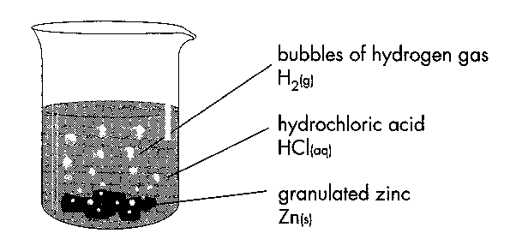
- A reaction rate can be determined by the rate of:
- disappearance of reactants.
- appearance of products.

- Consider the reaction of hydrochloric acid with zinc:

Zn _{(s)} + 2H⁺ _{(aq)} → Zn²⁺ _{(aq)} + H₂ _{(g)}

- What changes will take place in this reaction?

- The reaction rate of this reaction could be determined by observing the rate of any of these changes.

Measuring the rate of a reaction
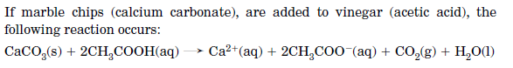

The rate of this reaction can be determined in both these ways:

or
Example:
- An experiment studying the rate of reaction between calcium carbonate and vinegar was carried out and these results were obtained:

Time(s) | 0 | 30 | 60 | 90 | 120
Mass of CO₂ formed (g) | 0 | 0.99 | 1.29 | 1.52 | 1.65

Calculate the average rate of the reaction:
- During the first 30 seconds

- In the 90 to 120 second time interval

NC p368-73 QS 9.1 p373
EC 14.1, 14.2 p 116-7
Collision theory can be used to explain and predict the effects of concentration, temperature, pressure, the presence of catalysts and surface area on the rate of chemical reactions
COLLISION THEORY AND ACTIVATION ENERGY

- Consider this reaction: 2HI _{(g)} → H_{2 (g)} + I₂ _{(g)}

- For every two molecules of HI _{(g)} which decompose, one molecule of H₂ _{(g)} and one molecule of I₂ _{(g)} are produced.
- This equation does not indicate how HI molecules are converted into H₂ and I₂.
- A collision occurs between the reactant particles: HI.

- Collision Theory - the collision theory assumes that if particles are to react they must first undergo an appropriate collision. The molecules must:
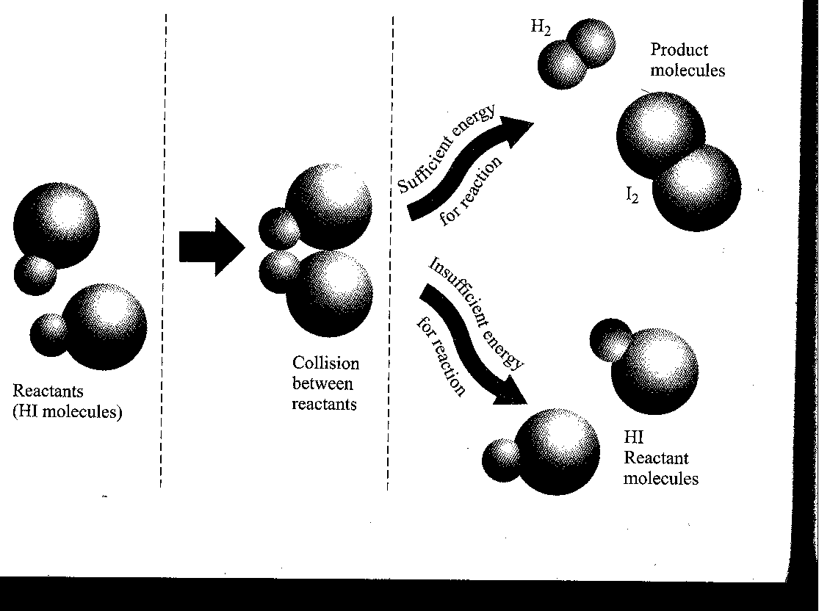
- collide with sufficient energy to disrupt the bonds of the reactant molecules.

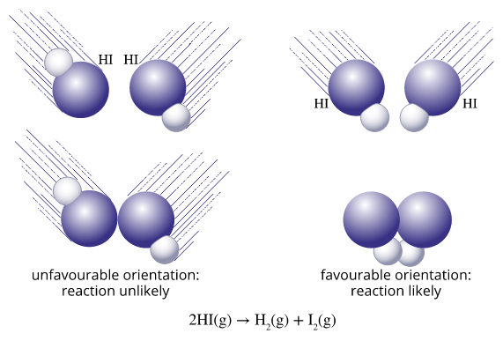
ii. collide with an orientation that is suitable for the breaking of some bonds and the formation of others.

- A collision can be classified as successful or unsuccessful.
EC 14.3 p117
The magnitude of the activation energy influences the rate of a chemical reaction

- Activation energy is the minimum energy that is required for a collision to result in a reaction.

- It is important that reactions have an orientation requirement since the relative orientation of reactant molecules must be favourable for the breaking of particular bonds and the formation of new bonds in the products.
- Many collisions between reactant are unsuccessful in producing a reaction.

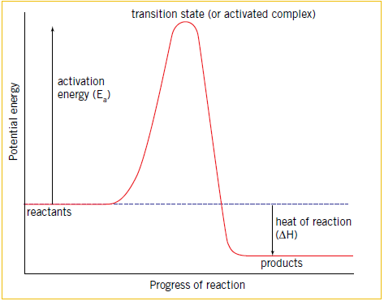
Energy profile diagrams, which can include the transition state and catalysed and uncatalysed pathways, can be used to represent the enthalpy changes and activation energy associated with a chemical reaction

Energy Profile Diagrams

- An energy profile diagram is a way of representing the energy changes that occur during a chemical reaction.

- Transition State - occurs between the reactant and the product states and is a very high energy state.
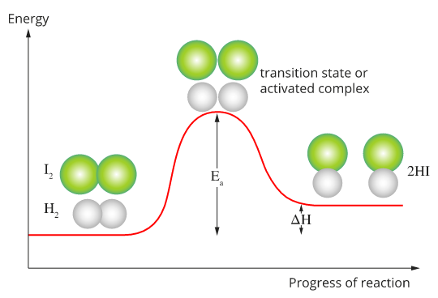
- This high energy state is known as the transition state or activated complex:

- represents the highest energy state for the reacting system.
- corresponds to some stage in the reaction at which bond-breaking and bond-formation are taking place.
- unstable state - temporary.

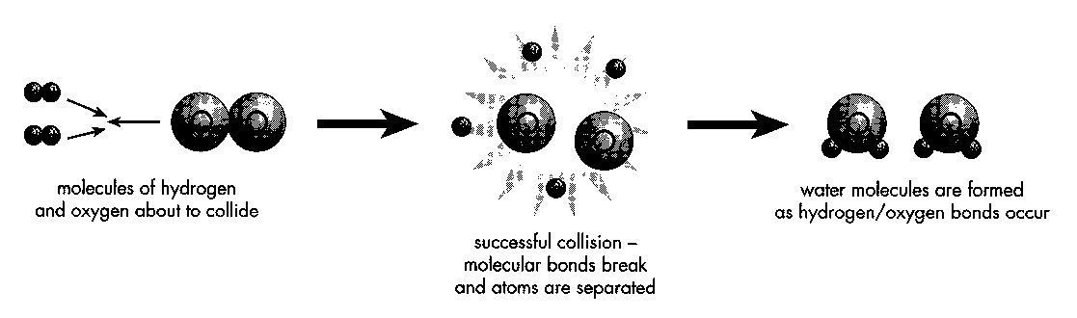

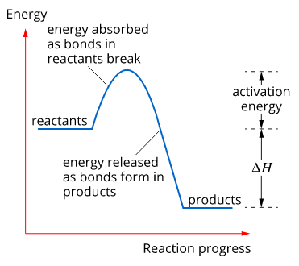

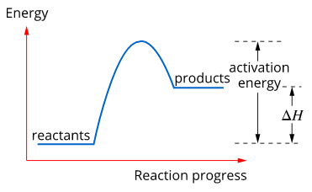

Energy profile diagram for an endothermic reaction.
Energy profile diagram for an exothermic reaction.

EC 14.4 p117
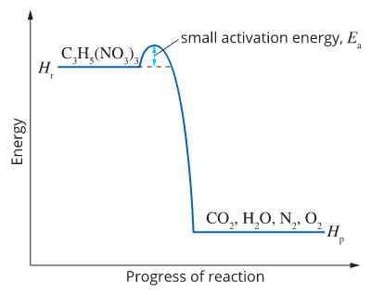

Energy profile diagram for the decomposition of the explosive nitroglycerine, C3H5(NO3)3.

The activation energy is the minimum energy required for a chemical reaction to occur and is related to the strength and number of the existing chemical bonds

- The activation energy of reactants
- determines whether or not a reaction will occur.
- is the difference in the potential energies of the reactants and the transition state.
- is a barrier which must be overcome for the reaction to take place - activation energy barrier.
- determines if a reaction will occur - when reactant molecules collide, a reaction will only occur if the energy of the collision is sufficient to supply the activation energy needed for the reaction to reach the transition state.

- The Rate of Reaction depends on the proportion of molecular collisions with enough energy to overcome the Activation Energy Barrier.

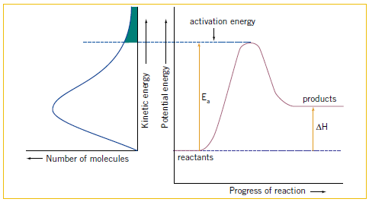
- This graph indicates that only a relatively small proportion of molecules in this system have energies greater than that of the activation energy barrier.
- In this system, few collisions would have sufficient energy to be successful in bringing about a reaction - thus reaction rate would be slow.

Energy Profile Diagrams for Exothermic and Endothermic Reactions

- These indicate that activation energy exists for both exothermic and endothermic reactions.
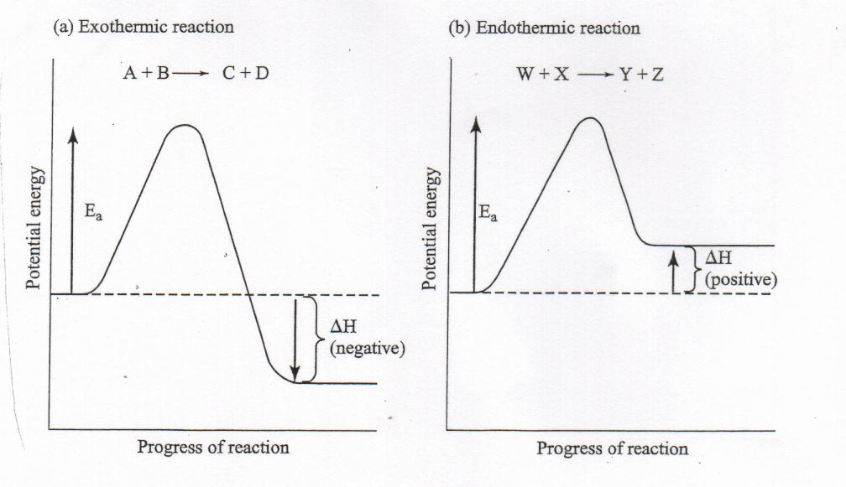
- In these particular examples, both reactions are depicted as having the same activation energy.
- This means that the same amount of energy is needed for a molecular collision to be successful in either direction

Reversibility of Reactions

Activation Energies for Reverse Reactions
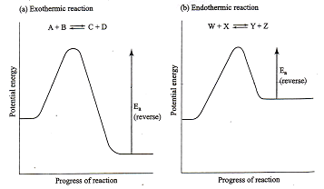
- In many reactions there is a significant reaction in the opposite direction in which product molecules react to regenerate the reactants.
- An example of such a reaction:

2HI _{(g)} H₂ _{(g)} + I₂ _{(g)}
- The activation energy for the reverse reaction is considerably higher for reaction (a) than for reaction (b). The reverse reaction for (b) will proceed at a faster rate.

PROBLEM SET

1. What factors determine whether a particular collision between reactant molecules will lead to a reaction?

2. A piece of white phosphorous left in the open air at room temperature spontaneously ignites and burn to form P₄O₁₀. In contract, a piece of iron rusts very slowly when exposed to the atmosphere. What does this information suggest about the activation energies for these reactions?

3. a. Draw energy profile diagrams for reaction which have the following activation energies and heats of reaction:

 | A | B | C
Activation Energy (kJ) | 100 | 50 | 120
Heat of Reaction (kJ) | -50 | -80 | +50

b. Assuming all other factors affecting the rates of these reactions are equal, identify the following:
• the fastest and slowest forward reaction
• the fastest and slowest reverse reaction

3. When nitrogen and hydrogen are heated under conditions of high temperature and pressure ammonia is formed. However, a sample of ammonia when heated produces nitrogen and hydrogen. Write an appropriate equation to present this reversible system.

NC p374-8 QS 9.2 p378

Varying the conditions under which chemical reactions occur can affect the rate of the reaction
FACTORS THAT AFFECT REACTIONS RATES

The factors that determine the rate of a reaction are:
        - Nature of reactants
        - Concentration
        - State of sub-division
        - Catalyst
        - Temperature

The Nature of the Reactants
- By examining many different reactions, chemists have produced some guidelines which are sometimes useful in helping predict reaction rates:

- If a reaction does not involve bonding rearrangement its it likely to be rapid at room temperature.
Ag⁺ _{(aq)} + Cl⁻ _{(aq)} → AgCl _{(s)}

- if a reaction involves the breaking of bonds it is likely to be slow at room temperature.
CH_{4 (g)} + 2O₂ _{(g)} → 2H₂O _{(g)} + CO₂ _{(g)}

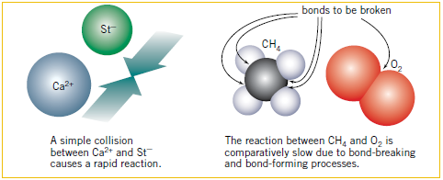

- Reactions involving molecular substances with covalent bond-breaking and covalent bond-forming requirements are likely to be slower than those involving the simple combination of oppositely charged ions.
- In the reactions involving molecules, the collisions must have enough energy to overcome the activation energy barrier;
- Slower reactions will have higher activation energies than faster reactions.
- different activation energy for different reactions are related to the ease with which bond-breaking and reforming processes occur.
- high activation energy are often associated with reactions in which strong bonds have to be broken.

The Concentrations (or pressure for gases) of the Reactants
- increasing the concentration of a reactant in a solution (or pressure for gases) increase the rate at which reactant molecules collide.
- greater number of collision, faster rate of reaction.
- same proportion of these collision will be successful as dilute solutions, but the greater the rate of collisions results in a greater number of successful collisions.

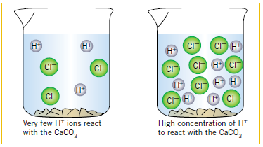

- The rate of reaction between HCl _{(aq)} and CaCO₃ _{(aq)} can be increased by increasing the concentration of HCl _{(aq).}

- A plentiful supply of oxygen is required to reignite a glowing splint.
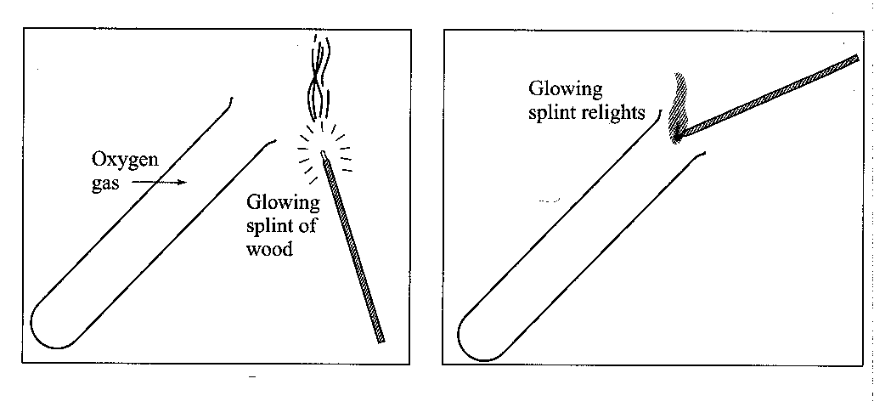

The State of Sub-Division of the Reactants (surface area)
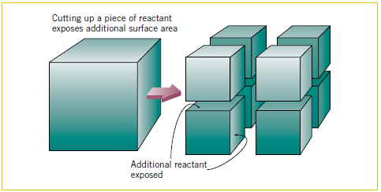
- By decreasing the size of the particles of the reactants, the rate of reaction increases because it increases the surface area of the reactants.

S _{(l)} + O₂ _{(g)} → SO_{2 (g)}

- A stream of liquid sulphur is sprayed into the combustion chamber through jets causing it to break up into numerous droplets resulting in a much faster rate of reaction.

- If the surface area of a solid or liquid is increased, more of the reactant molecules are exposed to collision.

Temperature

- increase in temperature increases the average kinetic energy of the reacting molecules and change the distribution of molecular kinetic energies.
- increased velocities of the molecules leads to a greater rate of collision and a greater reaction rate.
- greater proportion of reactant molecules have sufficient kinetic energy to supply the activation energy needed for reaction - a greater proportion of molecular collisions will be successful.
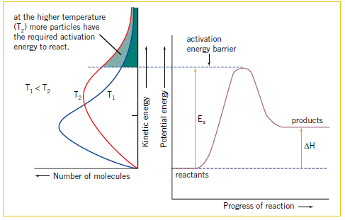

EC 14.5, 14.6 p118-20

Catalysts, including enzymes and metal nanoparticles, affect the rate of certain reactions by providing an alternative reaction pathway with a reduced activation energy, hence increasing the proportion of collisions that lead to a chemical change
Catalysts
- A catalyst is a substance that increases the rate of a chemical reaction without being permanently consumed in the reaction.
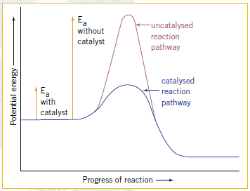
- provide an alternative pathway to that available when reactants are used alone - this different pathway has a lower activation energy.
- less collision energy is required for the reaction to take place - greater proportion of collisions will be successful and the reaction rate will be greater.
- greater proportion of reactant molecules have sufficient energy to overcome the activation energy barrier.
- allows reactions to be carried out at much lower temperatures.
- operate by forming intermediate compounds in which the bond-breaking and rearrangement process requires less energy than it the reactants alone were involved.
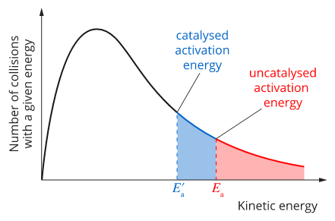

- Some catalysts provide a surface that creates a suitable site for more reactions to occur.
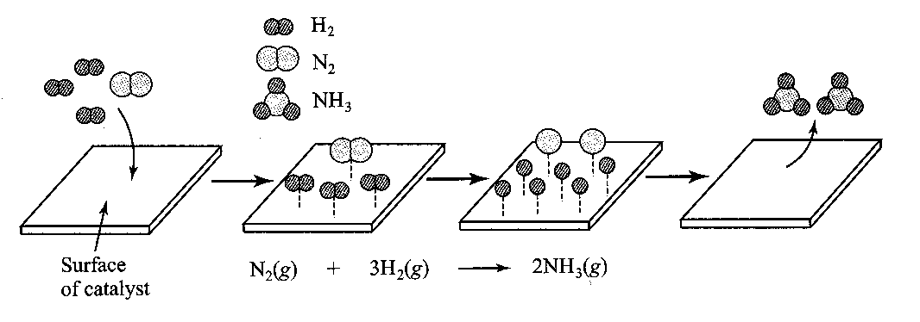

Examples

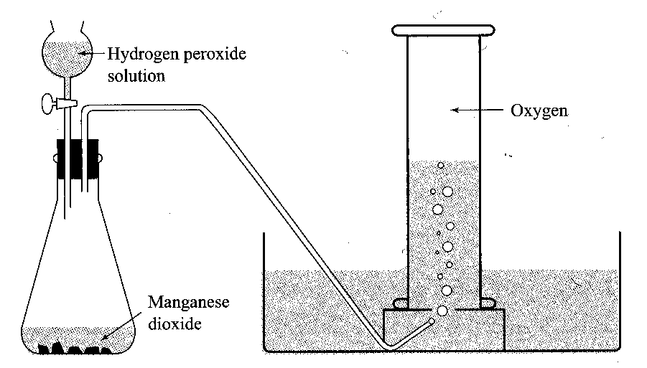
- MnO₂ is a catalysts used in the decomposition of H₂O₂ into O₂ gas and H₂O. A catalyst is not required in large amounts to alter the rate of reaction.
MnO₂

2H₂O₂ _{(aq)} O_{2 (g)} + 2H₂O _{(l)}

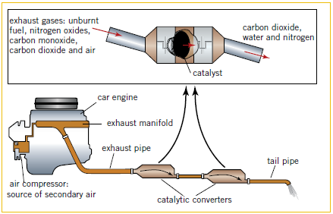
- Catalytic converters in cars contain platinum or rhodium. They catalyse the following reactions:

Turning harmful nitric oxide into nitrogen and oxygen.
2NO_{(g)} N_{2(g)} + O_{2(g)}
Converting unburnt octane into carbon dioxide and water.
2C₈H_{18(g)} + 25O_{2(g)} 16CO_{2(g)} + 18H₂O_{(g)}
Converting carbon monoxide into carbon dioxide.
2CO_{(g)} + O_{2(g)} 2CO_{2(g)}

- Metal nanoparticles (particles with a diameter less than 100 nm that behaves as a whole unit) have a far larger surface area than other metals due to their size and therefore have a greater impact on the reaction e.g. gold and copper nanoparticles as catalysts for fuel cells.

- Biological catalysts in our body are called enzymes and are usually made of protein.

EC 14.7, 14.8, 14.9 p120-1
NC p379-92 QS 9.3 p392

Questions on Chemical Reaction Rates, Collision Theory & Activation Energy

Collision Theory and Activation Energy

Collision theory assumes if particles are to react they must undergo appropriate collisions
Molecules must collide with
- sufficient energy to disrupt/break the bonds of the reactant molecules.
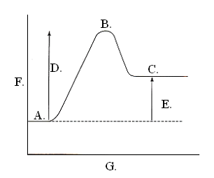
- an orientation that is suitable for the breaking of some bonds and the formation of others.
Energy Profile Diagrams:
1. Label the following activation energy diagram with:
- reactants
- transition state
- products
- activation energy (E_{a})
- heat of reaction (ΔH)
- potential energy
- progress of reaction

3. Explain the following terms:
- activation energy
minimum energy required for a collision to result in a reaction
- transition state
occurs between reactants and products and is high energy state.
- Activation complex
Transition stage between reactants and products
- reaction mechanism
series of steps for a reaction
- intermediates
steps in reaction that are not reactants or products
- Rate-determining step:
Slowest step in reaction, speed of reaction can’t go faster than slowest step.

  - Is a reaction more likely to occur if the activation energy is high or low? Low

  - Using the energy profile diagram, explain what determines if a reaction will occur.
A reaction will occur if:
a. molecules collided with enough energy to disrupt bonds and overcome activation energy.
b. must collide with appropriate orientation suitable to break bonds and form other bonds.

  - The diagram shows a reaction with high activation energy and a slow reaction. Draw a similar diagram to show a fast reaction.

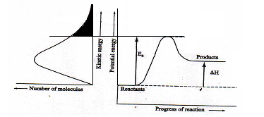
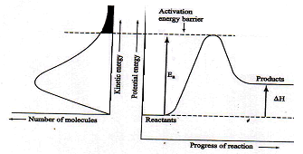

  - Draw the following energy profile diagram
a. Fast endothermic reaction b. Slow exothermic reaction
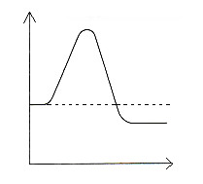
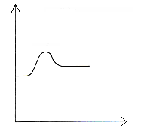

  - Some reactions are reversible with the reactants reforming from the products. Each of the following is a reversible reaction. For each of the following state
  - if the reaction is exothermic or endothermic.
  - if the forward or reverse reaction is more likely to be the faster reaction.
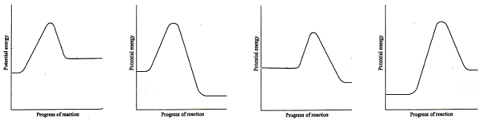
Endothermic Exothermic Exothermic Endothermic
Reverse Forward Forward Reverse

Rates of Chemical Reactions and applying the Collision Theory:
Reaction rate determined by rate of disappearance of reactants and rate of appearance of the
products . Observing any change within a reaction can determine rate of reaction.
The rate of chemical reactions is affected by five factors:
- Nature of the reactants:
a. Reactions NOT involving bond re-arrangement will be rapid (rapid or slow at room temp.)
for example ppt reactions such as silver ions and chloride ions forming silver chloride
These reactions will have a lower (higher/lower?) activation energy
b. Reactions that DO involve bond re-arrangement will be slower
for example burning of methane gas in oxygen to produce water and carbon dioxide gas
These reactions will have a higher (higher/lower?) activation energy
c. Strong bonds usually have a higher (higher/lower?) activation energy
- Concentration of the reactants:
a. Increasing concentration of any of the reactants can increase rate of reaction
for example: using a higher molarity acid in a reaction
b. Changing the concentration does NOT change the activation energy. Explain why increasing
concentration of reactions increases rate of reaction.
  - Increases rate at which reactants will collide.
  - As greater number of collisions, faster rate of reaction
  - Same proportion of reactions successful as dilute solutions but as more collisions, greater number of successful collisions.
- State of sub-division of reactants:
a. Using powders, sprays, granules – all increase surface area of reactants and hence its access to the other reactant/s in the reaction. A simple example is chopping a log of wood into smaller pieces for a fire – increases surface area of wood exposed to oxygen and flame.
Another example is
S _{(l)} + O_{2 (g)} → SO_{2 (g)} Sulfur is sprayed in jet so liquid breaks into droplets
b. Explain how the collision theory relates to sub-division.
Greater surface area means that more of the reactant molecules are exposed to collide so greater number of successful collisions.
- Temperature:
a. Increase in temperature often results in increase in reaction rate as more particles given enough kinetic energy for successful collisions and formation of product. For example:
hydrogen gas and oxygen gas will not combine unless heat is applied
b. Increasing the temperature increases the kinetic energy of the molecules and hence their
velocity . Increase in velocity leads to a greater rate of collisions and a
greater reaction rate.
c. How does greater kinetic energy and velocity relate to activation energy of the reaction?
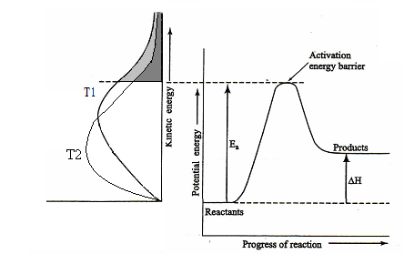
Greater proportion of molecules have higher kinetic energy and hence higher velocities. More molecules collide with greater velocity and more energy so more can overcome activation energy.

d. On the following diagram, show what happens to the number of molecules with enough kinetic energy to overcome activation energy barrier when temperature is DECREASED.

- Catalysts:
a. Catalysts increase rate of reaction without themselves being used up although they do take part in the reaction. Catalysts are not included in the reaction but is written above the arrow. For example
chlorophyll

photosynthesis: 6CO_{2 (g)} + 6H₂O_{(l)} + energy C₆H₁₂O_{6 (aq)} + 6O_{2 (g)}
here, the catalysts is chlorophyll . Write the equation for the production of
oxygen gas with MnO₂ as the catalyst:

b. A catalysts doesn’t reduce the activation energy pathway but rather provides an alternative
pathway for the reaction. This pathway has a lower activation energy so a greater number of collisions will be successful and reaction rate greater as a greater proportion of molecules have sufficient energy to overcome catalysed reaction pathway.
  - Reaction can also be carried out at a much lower temperature.
  - Catalysts form an intermediate compound in which bond-breaking and re-arrangement processes require less energy than reactants alone.
e. Draw
    - a potential energy/progress graph of reaction graph showing with and without a catalyst.
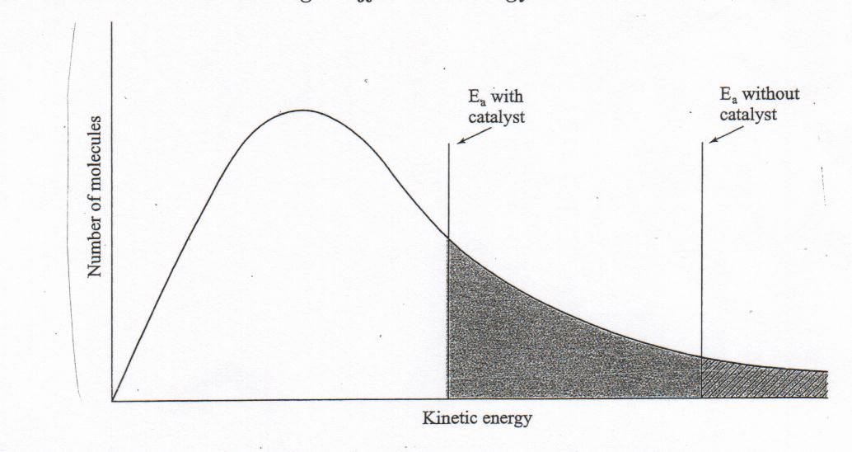
    - a graph showing the number of molecules with sufficient kinetic energy for a reaction to occur with and without a catalyst.

Questions:
      - Consider the reaction Mg_{(s)} + 2H⁺_{(aq)} → Mg²⁺_{(aq)} + H_{2 (g)}. By observation, describe two ways we could measure the rate of the reaction.

Rate of disappearance of solid magnesium
Rate of appearance of hydrogen gas
      - Suggest reasons for the difference in rate of the following reactions at room temperature:
Fast: Cu²⁺_{(aq)} + CO₃²⁻_{(aq)} → CuCO_{3 (s)}
Slow: C₆H₁₂O_{6 (aq)} + 6O_{2 (g)} → 6CO_{2 (g)} + 6H₂O_{(l)}
Low reaction involves the breaking of many covalent bonds and consequently would have a high activation energy. The fast reaction does not involve the same sort of bond-breaking processes and would therefore have a lower activation energy.

      - Predict the effect of increasing the pressure of oxygen on the rates of the following reactions.
- 2SO_{2 (g)} + O_{2 (g)} → 2SO_{3 (g)} increase rate (greater concentration)
- 4Na _{(s)} + O_{2 (g)} → 2Na₂O _{(s)} increase rate (greater concentration)
- Ag⁺_{(aq)} + Cl⁻_{(aq)} → AgCl _{(s)} no effect
- 2H₂O_{2 (aq)} → O_{2 (g)} + 2H₂O_{(l)} no effect

      - When hydrogen gas is prepared in the laboratory, hydrochloric acid is usually added to granulated rather than powdered zinc. Suggest why.

The surface area of powdered zinc would be much higher than granulated zinc, leading to a much faster reaction. Using granulated zinc, hydrogen is produced at a steady, easily manageable rate.

      - When dilute acid is added to sodium thiosulfate solution a precipitate of sulfur is formed.
S₂O₃²⁻_{(aq)} + 2H⁺_{(aq)} → S _{(s)} + SO_{2 (aq)} + H₂O _{(l)}
If it takes 30 seconds for a precipitate to appear using 0.05 mol L⁻¹ Na₂S₂O₃ solution, estimate what time it might take if the Na₂S₂O₃ solution was 0.10 mol L⁻¹. Show your reasoning.

As the concentration has doubled, the time should halve so the time would be 15 seconds

      - a. Why must reactant molecules collide with an energy greater than a certain minimum value for reaction to occur? Colliding reactant molecules must supply the activation energy needed for the reaction to reach the transition state. This energy is needed so that required bond breaking and bond forming can take place to allow the reactants to be converted into products.
b. Will every collision which has this minimum energy result in the formation of products? Explain.
No necessarily. The orientation of the colliding reactant molecules must also be considered.

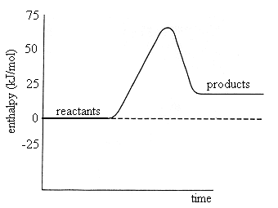
      - Use the energy profile diagram to the right to answer the following questions.
- Is the reaction exothermic or endothermic?
endothermic
- What is the value of ΔH for the forward reaction?
ΔH = +24 kJ
- What is the activation energy for the forward and reverse reactions?

Forward 70 kJ reverse 55 kJ
- A catalyst for the reaction lowers the activation energy by 10 kJ mol⁻¹. In the presence of the catalyst what is the activation energy of the forward and reverse reactions.

Forward 60 kJ reverse 45 kJ
- How does the catalyst affect the rate of the forward and reverse reactions.
It lowers the activation energy so both are increased.

      - For the following reactions draw energy profile diagrams, indicating the potential energies of the reactants and products and the activation energy for the reaction.
- A piece of sodium added to water reacts rapidly to produce hydrogen and sodium hydroxide solution. The reaction is accompanied by the release of considerable quantities of heat.

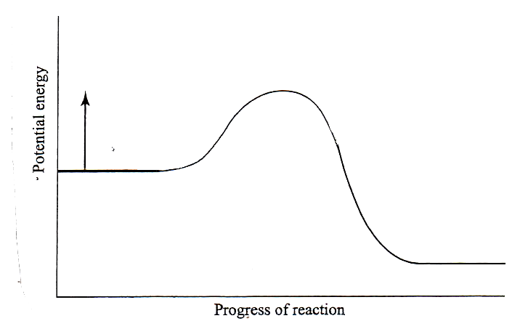
Exothermic and rapid

- A mixture of N_{2 (g)} and O_{2 (g)} when heated very strongly is converted to NO_{(g)}. The reaction is endothermic.

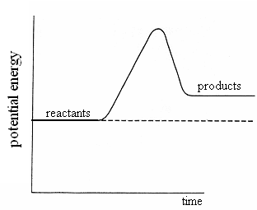
High Activation energy - slow

      - A common misunderstanding regarding catalysts is that ‘they speed up a reaction but take no part in the reaction’. Explain what is wrong with this statement.

Catalysts provide an alternative pathway from that available when the reactants are used alone. They act by forming intermediate substances in which bond breaking and rearrangement processes require less energy than if the reactants alone were involved. A catalyst therefore takes part in a reaction. However catalysts are not consumed in chemical reactions; they are regenerated when the reaction is complete.

SUMMARY OF ENERGY EFFECTS

Energy Effects:

- Heat of Reaction: Amount of heat released or absorbed when specified amounts of substances react.
- Exothermic Reactions: mixture becomes hotter and release heat to surroundings.
- Endothermic Reactions: mixture becomes colder and absorbs heat from surroundings.
- Heat Content: Sum of chemical and potential energy of the molecules or ions of a specified amount of a substance. If total heat content of reactants greater than products excess energy released – exothermic. If total heat content of reactants is less than products, energy absorbed – endothermic.
- Enthalpy: Change in heat content. Symbol H. Enthalpy not measured directly only changes in it - ΔH. ΔH = H(products) – H(reactants). (Δ - pronounced delta and represents change in magnitude.)
ΔH for exothermic reactions is negative compared to surroundings (why?)
ΔH for endothermic reactions is positive compared to surroundings (why?)
- Origin of heats of reaction: When bonds broken or formed, heat absorbed or released. When a single reaction takes place, heat of reaction equal to the heat released or absorbed. However, many reactions are a sequence of chemical reactions and the heat of reactions is equal to the algebraic sum of each individual reaction. For example:
H_{2 (g)} + Cl_{2 (g)} → 2HCl _{(g)} ΔH = 185 J
H-H bond broken H = +437 kJ x 1 mol = +437 kJ
Cl –Cl bond broken H = +244 kJ x 1 mol = +244 kJ
H-Cl bond formed H = -433 kJ x 2 mol = -866 kJ total ΔH = -185 kJ
- In solids, force of attraction between particles is much stronger than gases and therefore magnitude of the heat of reaction is partly dependent on this force. For example heat must be added to solid iodine for sublimation to occur. I_{2 (s)} → I_{2 (g)} ΔH = +62 kJ
- When reaction involves different phases, sequence of chemical reactions can become more complex. For example: NH_{3 (g)} + HCl _{(g)} → NH₄Cl _{(s)}
- heat absorbed when HCl bond broken.
- heat released when ammonium ion formed
- heat released when ammonium chloride solid lattice formed.
For this reason, the subscripts (s), (l), and (g) become very important.

Rates of Reaction:
- Units: moles per time unit
- Factors affecting: Temperature, nature of reactants, concentration, subdivision, catalyst.
- Concept of reaction rate: determined by (i) rate of disappearance of reactants; (ii) rate of appearance of products.
- Collision Theory: Collision must occur for reaction to proceed. Rate of collisions directly relates to rate of reaction. Appropriate collision orientation on collision.
- Effect of Concentration: Concentration equals number of particles per unit volume, increase concentration results in increase in collision rate

Greater number have sufficient energy for reaction to occur
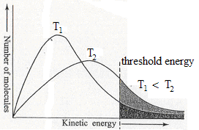
- Effect of temperature: For collisions to be effective in causing chemical change they require a minimum energy of collision (Threshold Energy). An increase in temperature results in more pairs of particles possessing this threshold energy. An increase in temperature means an increase in the number of collisions per time unit . But the increase in the number of effective collisions per time unit is a far more important factor.

- Subdivision: Increase surface are increases rate.
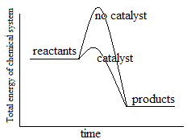
- Catalysts: provide an alternative pathway for the reaction mechanism to follow (see below). Activation energy of catalysed reaction lower than without catalyst. Not consumed although it does take part in reaction. Does not affect ΔH. Speeds up forward and reverse reaction. Allows reaction to proceed faster at lower temp.

Activation Energy:
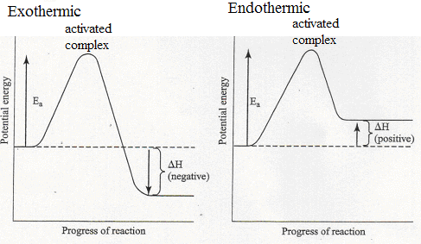
- Activation complex: transition stage between reaction and produces (top of peak of reaction curve)
- Activation Energy (E_{a}): minimum energy required for collision to result in a reaction (energy colliding particles must have to form activated complex)
- Fast reactions have a low activation energy, slow reactions have a high activation energy.
- Reaction mechanism: series of steps for reaction.
- Intermediates: steps that are not reactants or products.
Rate-determining step: slowest stope in reaction, speed of reaction cannot go faster than the s

